CS 255 System Design Document

UML Diagrams

UML Use Case Diagram

This diagram shows the system functions available to the customer, the secretary, the instructors, the owner, and the IT admin. It also includes the DMV update source as an external service. The system will need to enforce package access and employee permissions.

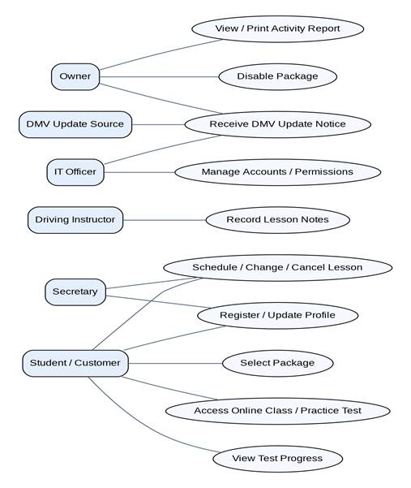

UML Activity Diagrams

This allows a customer or secretary to book a two-hour lesson, pick an available instructor and vehicle, and get confirmation. The system will need to check availability once more when saving to ensure there's no overlap. Each booking action is logged.

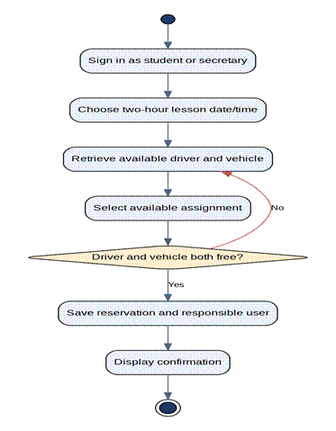

This applies to students whose package includes the online practice tests. The system will record the test completion, time taken, score and status so that both the student and staff can monitor progress.

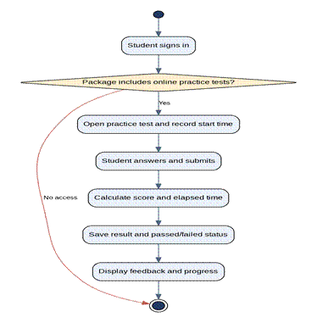

UML Sequence Diagram

This is the student/secretary, web interface, scheduling service, and database all working together to book something. The database checks availability prior to the booking being saved and records who made the change.

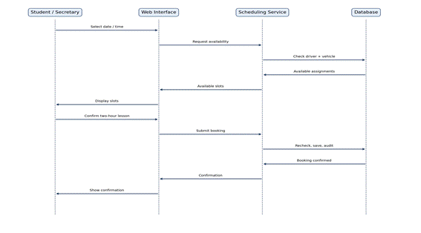

UML Class Diagram

The class model splits out the users, students, training packages, appointments, instructors, vehicles, tests, results, notes, and audit events. It supports reservations, two-hour lesson booking, package access, progress assessment, and accountability. The attribute types and cardinalities are the proposed design details which will be validated.

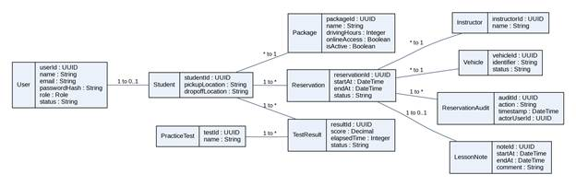

Technical Requirements

Hardware

DriverPass requires internet-connected computers for office staff and compatible desktops or mobile devices for customers and instructors. Cloud-hosted application and database servers are recommended (so DriverPass doesn't have to maintain its own dedicated servers on site). Staff will need reliable network access and suitable printers for the activity reports.

Software

The proposed solution is a web app with a browser interface, server-side application services, and a relational database. The database will store accounts, role permissions, customer profiles, packages, reservations, instructor and vehicle assignments, lesson notes, practice test results, and audit history. A payment processor will be used to securely handle payment information and will not store any card security codes.

Tools

Lucidchart is needed for the UML diagrams as part of this assignment. In the implementation phase, the developers would be using version control, a dev environment, automated tests, and monitoring tools. The tests would be verifying package eligibility, the two-hour lesson duration, no instructor/vehicle overlap, permission boundaries, account resets, and the accuracy of the reservation audit report.

Infrastructure

Managed cloud hosting should provide encrypted HTTPS, a secure database, backups and recovery processes, and access monitoring. Role-based permissions should be in place to limit the capabilities of students, secretaries, tutors/instructors, owners, and IT officers. Passwords should be stored as secure hashes, login attempts should be limited, and sensitive data should be protected. Only the connected user should be able to change system records, and only authorized users should be able to download reports for offline analysis.

External Integrations and Constraints

DriverPass wants to be alerted when DMV rules, policies, or sample questions change. The interview doesn't actually state that there is a DMV interface available, so integration is going to be dependent on an external source being supported, and that has to be confirmed. The client hasn't specified a budget, an uptime guarantee, a data retention period, or a number of concurrent users. A two-second response time is a proposed acceptance criterion from Project One, not a client requirement. Adding in entirely new software modules is outside of the initial release, and authorized staff can turn off the existing packages.

Source Basis

Southern New Hampshire University. (n.d.) CS 255 DriverPass interview transcript [Course document].

Bowman, R. (2026). CS 255 Project One business requirements document [Unpublished course assignment].

